Digits, Numbers, and Numerals
# Source: AI Source: Provided by: [Data Path: Persons Table -> ID Column: 1, Name_En Column: Motasem Essam] -> From: [ChatGPT] on [7/11/2026]
Digits, numbers, and numerals are three closely related concepts in arithmetic. Although they are often used interchangeably in everyday language, they have different meanings.
- A digit is a single symbol used to write numbers.
- A number is a mathematical concept that represents quantity or value.
- A numeral is the written or symbolic representation of a number.
Understanding the difference between these three concepts is one of the first steps in learning arithmetic.

1- Digit
# Source: AI Source: Provided by: [Data Path: Persons Table -> ID Column: 1, Name_En Column: Motasem Essam] -> From: [ChatGPT] on [7/11/2026]
A digit is a single symbol used to represent numbers. In the decimal (base-10) number system, there are ten digits.

Definition
# Source: AI Source: Provided by: [Data Path: Persons Table -> ID Column: 1, Name_En Column: Motasem Essam] -> From: [ChatGPT] on [7/11/2026]
A digit is one of the symbols:
0,1,2,3,4,5,6,7,8,9
These ten symbols are used to write all numbers.

Examples
# Source: AI Source: Provided by: [Data Path: Persons Table -> ID Column: 1, Name_En Column: Motasem Essam] -> From: [ChatGPT] on [7/11/2026]
- 7 is a digit.
- 0 is a digit.
- 9 is a digit.
In the number 582:
- 5 is a digit.
- 8 is a digit.
- 2 is a digit.
The number contains 3 digits.

Real-Life Examples
# Source: AI Source: Provided by: [Data Path: Persons Table -> ID Column: 1, Name_En Column: Motasem Essam] -> From: [ChatGPT] on [7/11/2026]
- Telephone numbers consist of digits.
- PIN codes are made of digits.
- ZIP codes are made of digits.
- Calculator buttons represent digits.
- Digital clocks display digits.

Conclusion
# Source: AI Source: Provided by: [Data Path: Persons Table -> ID Column: 1, Name_En Column: Motasem Essam] -> From: [ChatGPT] on [7/11/2026]
A digit is a single numerical symbol used to write numbers.

2- Number
# Source: AI Source: Provided by: [Data Path: Persons Table -> ID Column: 1, Name_En Column: Motasem Essam] -> From: [ChatGPT] on [7/11/2026]
A number is a mathematical idea used to represent quantity, position, measurement, or value.

Definition
# Source: AI Source: Provided by: [Data Path: Persons Table -> ID Column: 1, Name_En Column: Motasem Essam] -> From: [ChatGPT] on [7/11/2026]
A number is a mathematical object used for counting, measuring, ordering, or performing calculations.
Unlike a numeral, a number is an abstract concept rather than a written symbol.

Examples
# Source: AI Source: Provided by: [Data Path: Persons Table -> ID Column: 1, Name_En Column: Motasem Essam] -> From: [ChatGPT] on [7/11/2026]
- 5 represents the quantity five.
- 120 represents one hundred twenty.
- 3.14 represents the mathematical value pi (approximately).
- −7 represents a negative quantity.

Illustration
If there are
🍎🍎🍎🍎🍎
there are five apples.
The quantity "five" is the number.

Real-Life Examples
# Source: AI Source: Provided by: [Data Path: Persons Table -> ID Column: 1, Name_En Column: Motasem Essam] -> From: [ChatGPT] on [7/11/2026]
- Number of students in a class.
- Number of books on a shelf.
- Number of cars in a parking lot.
- Temperature measurements.
- Distances.

Conclusion
# Source: AI Source: Provided by: [Data Path: Persons Table -> ID Column: 1, Name_En Column: Motasem Essam] -> From: [ChatGPT] on [7/11/2026]
A number represents a quantity or value.

3- Numeral
# Source: AI Source: Provided by: [Data Path: Persons Table -> ID Column: 1, Name_En Column: Motasem Essam] -> From: [ChatGPT] on [7/11/2026]
A numeral is the written or symbolic representation of a number.
Different numeral systems can represent the same number using different symbols.

Definition
# Source: AI Source: Provided by: [Data Path: Persons Table -> ID Column: 1, Name_En Column: Motasem Essam] -> From: [ChatGPT] on [7/11/2026]
A numeral is a symbol or group of symbols used to write a number.

Examples
# Source: AI Source: Provided by: [Data Path: Persons Table -> ID Column: 1, Name_En Column: Motasem Essam] -> From: [ChatGPT] on [7/11/2026]
The same number can have different numerals.
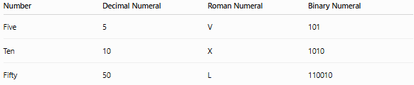
Number | Decimal Numeral | Roman Numeral | Binary Numeral
Five | 5 | V | 101
Ten | 10 | X | 1010
Fifty | 50 | L | 110010
Each numeral represents the same mathematical number.

Illustration
The number "ten" can be written as
- 10
- X
- 1010₂
These are different numerals representing the same number.

Real-Life Examples
# Source: AI Source: Provided by: [Data Path: Persons Table -> ID Column: 1, Name_En Column: Motasem Essam] -> From: [ChatGPT] on [7/11/2026]
- Roman numerals on clocks.
- Decimal numerals in textbooks.
- Binary numerals in computers.
- House numbers.
- Page numbers.

Conclusion
# Source: AI Source: Provided by: [Data Path: Persons Table -> ID Column: 1, Name_En Column: Motasem Essam] -> From: [ChatGPT] on [7/11/2026]
A numeral is the written representation of a number.

Difference Between Digit, Number, and Numeral
# Source: AI Source: Provided by: [Data Path: Persons Table -> ID Column: 1, Name_En Column: Motasem Essam] -> From: [ChatGPT] on [7/11/2026]
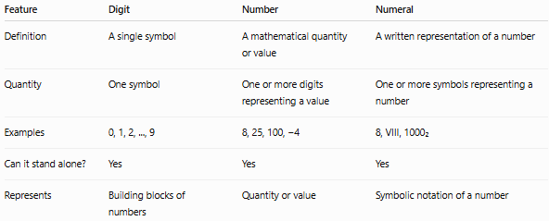
Feature | Digit | Number | Numeral
Definition | A single symbol | A mathematical quantity or value | A written representation of a number
Quantity | One symbol | One or more digits representing a value | One or more symbols representing a number
Examples | 0, 1, 2, ..., 9 | 8, 25, 100, −4 | 8, VIII, 1000₂
Can it stand alone? | Yes | Yes | Yes
Represents | Building blocks of numbers | Quantity or value | Symbolic notation of a number

Relationship Between Them
# Source: AI Source: Provided by: [Data Path: Persons Table -> ID Column: 1, Name_En Column: Motasem Essam] -> From: [ChatGPT] on [7/11/2026]
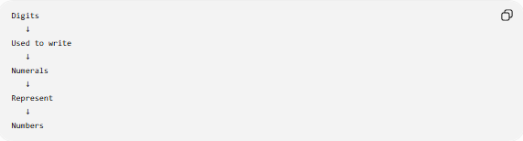
Digits
↓
Used to write
↓
Numerals
↓
Represent
↓
Numbers
Example:
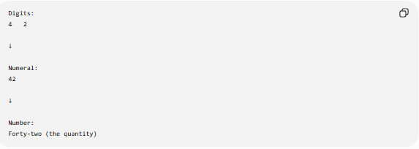
Digits:
4 2

↓

Numeral:
42

↓

Number:
Forty-two (the quantity)

Real-Life Analogy
# Source: AI Source: Provided by: [Data Path: Persons Table -> ID Column: 1, Name_En Column: Motasem Essam] -> From: [ChatGPT] on [7/11/2026]
Imagine writing a word.
- Letters → Digits
- Word → Numeral
- Meaning of the word → Number
Example:
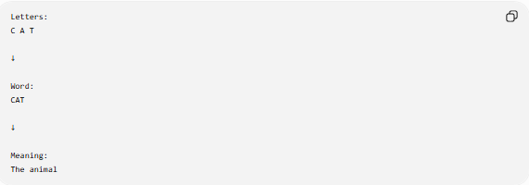
Letters:
C A T

↓

Word:
CAT

↓

Meaning:
The animal
Similarly,
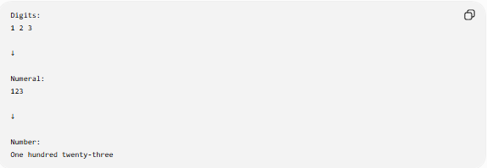
Digits:
1 2 3

↓

Numeral:
123

↓

Number:
One hundred twenty-three

Memory Tip
Remember the sequence:
- Digit → One symbol (0–9)
- Numeral → The written form (e.g., 245, XLV, 1011₂)
- Number → The mathematical value or quantity
A simple way to remember is:
Digits build numerals, and numerals represent numbers.

